AI Project
Topic: AI-Powered Personalized Learning Companion

Day – 1

Problem Statement:
Traditional education systems follow a one-size-fits-all approach, where:
- All students are taught at the same pace
- No personalization based on individual ability
- Limited feedback on weak areas
Core Problem:
Slower learners struggle to keep up, while advanced learners lose interest due to lack of challenge.
This leads to:
- Reduced engagement
- Poor concept retention
- Inefficient learning outcomes
Project Objective:
To develop an AI-powered web application that:
- Adapts to each student's learning pace
- Generates personalized learning paths
- Provides real-time tutoring using AI
- Uses spaced repetition for long-term retention

Scope Definition
To ensure feasibility and accuracy:
MVP Scope:
- Focus on ONE subject only:
Computer Science (Data Structures & Algorithms)
- Features included:
  - Diagnostic quiz
  - AI conversational tutor
  - Personalized learning path
  - Flashcards with spaced repetition
Excluded (for MVP):
- Multi-subject support
- Voice assistant
- Advanced ML models
Core Features
- Diagnostic Quiz
- AI Chat Tutor
- Learning Path Generator
- Spaced Repetition System (FSRS)
- Progress Dashboard
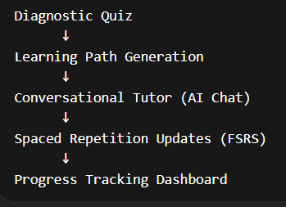

System Flow of the Project

Team Roles & Responsibilities (5 Marks)
Frontend Team (3 Members)
- Develop UI using React
- Implement:
  - Dashboard
  - Chat interface
  - Quiz pages
Backend Team (2 Members)
- Develop FastAPI APIs
- Handle:
  - Authentication
  - Data flow
  - API endpoints
LLM / RAG Team (2 Members)
- Implement:
  - LangChain pipelines
  - Prompt engineering
  - Context-aware responses
- Manage:
  - Vector database (ChromaDB)
Educational Algorithms Team (2 Members)
- Implement:
  - FSRS spaced repetition
  - Adaptive quiz logic
  - Learning path generation
Project Manager (1 Member)
- Coordinate team tasks
- Manage GitHub repository
- Prepare documentation & presentation

Algorithm Behind our Project:
- Design Learning Path Algorithm
- Design Adaptive Quiz Logic
- Design FSRS (Spaced Repetition Logic)
- Weak Topic Detection Logic
- Define Data Inputs & Outputs
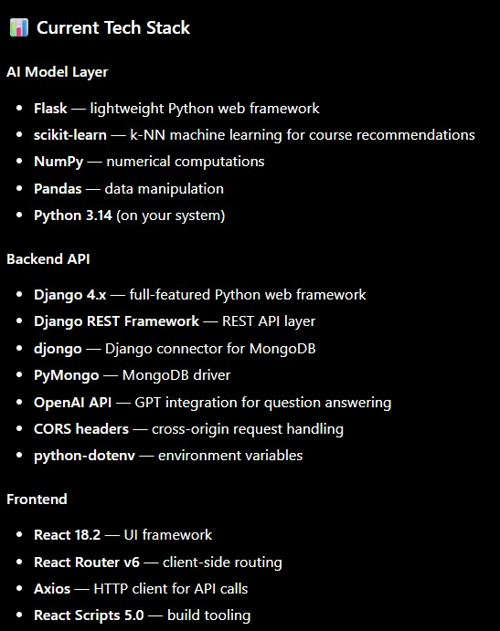

DAY – 2

Frontend Development (Completed):
The Frontend Team completed a fully functional user interface.
Key Achievements:
- Fully functional UI
- Different features added
- Functional Dashboard
- Quick Action Features added

Backend Development:
- Django Connected
- Flask Connected
RAG Pipeline Made

